8. Flood Risk Assessment.
8.1 Summary,
The area of Canal to be restored is at the North of Selly Oak Park and runs East to West from Harborne Road Bridge in the East to the edge of the Park in the West. The Environment Agency confirms that this is not recognised as a flood risk area
The canal link access to the Worcester to Birmingham Canal was blocked in 1953 and following this water draining off the park resulted in a flooding incident in 1958. Following this incident the Council installed a drainage and silt trap system and water is now discharged by a pipe that runs northwards between 71 and 75 Reservoir Road and acts as a connection to the sewers that eventually discharge to the Bourn Brook.
This drain will remain in place until the link to the Worcester and Birmingham Canal is completed, it will then become redundant and be modified to provide an overflow drain
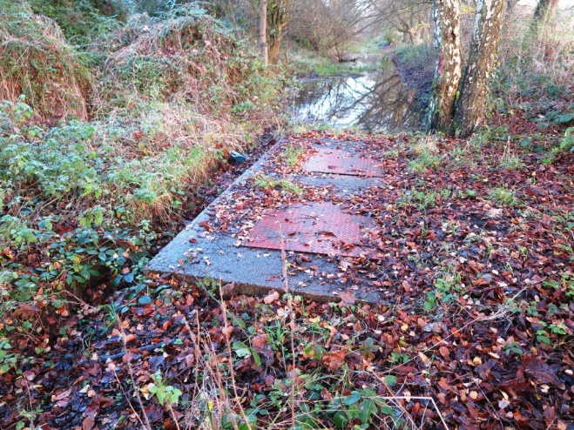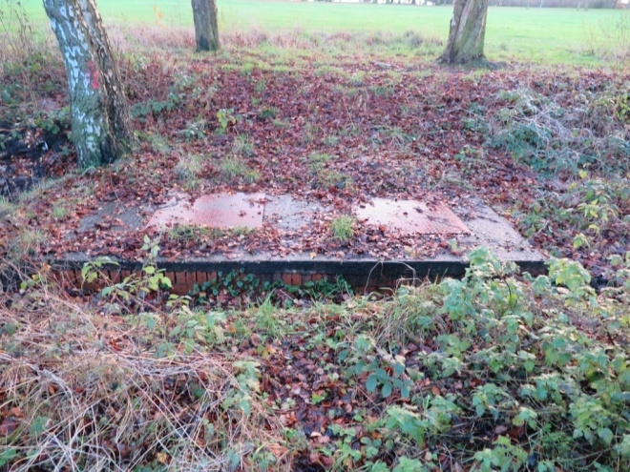
View of collector drain to be retained

8.2 Hydrogeology (Source Atkins report)

The relevant Groundwater Vulnerability Map prepared by the Environment Agency indicates that the Wildmoor Sandstone, which is shown by the BGS to underlie the site, is recorded as a Major Aquifer of high permeability. The overlying soils are classed as „Urban‟.

This categorisation assumes a worst case high vulnerability classification for leaching potential, relating to the downward passage of water and possible contaminants.
Major aquifers are defined as highly permeable formations usually with a known or probable presence of significant fracturing. They may be highly productive and able to support large abstractions for public supply and other purposes. Information obtained from the Environment Agency, included within the Envirocheck Report confirmed the following:
There is one record of a licensed surface water abstraction within 500m of the site. The abstraction is located approximately 390m to the east of the site and relates to the abstraction of surface waters for cooling purposes. There are no records of any groundwater abstractions within 500m of the site. There are no records of any discharges consents within 250m of the site.
The site is located with a Zone III (total catchment) Source Protection Area. Source protection zones I (outer protection Zone) and II (Inner Protection Zone) are located 700m and 350m respectively to the northeast of the site. The groundwater „source‟ is located approximately 750m to the northeast.
There are three recorded pollution incident within 500m of the site, all of which are classed as category 3 (minor incidents). The incidents are located 120m to the northeast, 270m to the northeast and 340m to the northeast and relate to crude sewage or miscellaneous pollutants entering the River Cole and River Rea (tributaries of the Trent catchment).
The information indicates that the site is not at risk of flooding from rivers.
8.3 Storm Water and Foul Water Management. (Source Atkins report)

Sewer records obtained from Severn Trent Water indicate that drainage has been installed along the route of the former canal. This starts at the eastern end close to the new Harborne Lane Bridge and flows north-west and then west, continuing along the canal west of the park boundary.
It seems that this later section (outside of the scope of this study) is private drainage. It is likely that this drainage was designed to act as a filter drain to drain the former canal bed to reduce the volume of water standing in the canal. However, it is assumed that this system no longer fulfils this function as parts of the canal are filled with water. No other connection to this pipe off line of the canal is indicated.
Records indicate that this drain bifurcates along the northern edge of the park. One pipe runs northwards between 71 and 75 Reservoir Road acting as a connection to the sewers that eventually discharge to the Bourn Brook. The second pipe continues to flow westwards along the former line of the canal.
This may be an issue with the records and it is probably that in reality the chamber brings flows together from the canal to the east and west of the chamber and there is a single discharge to public sewer via the pipe running northwards between 71 and 75 Reservoir Road. Records indicate that the chamber invert level of the bifurcation chamber (on the proposed line of the canal) is 136.09m aOD, and the invert of the connecting manhole in Reservoir Road is 132.21m aOD.
The difference between these two exceeds four metres so it is not feasible that the system was installed to take flow from Reservoir Road and store this in the canal. It is however likely that the drainage has been placed to drain the canal and utilise the former canal as storage for the runoff from the park, before discharging this via Reservoir Road to the Brook.

8.4 Maintaining Water Levels(Source Atkins report)

The canal in Selly Oak Park effectively captures surface water run-off from the majority of the park. The area of this catchment is approximately 11.25 hectares, and given a Standard Average Annual Rainfall (SAAR) for the location of 766mm/year and an estimated run-off percentage of 75% (based on the geology, slope of the site, etc.), this would give an annual average inflow to the canal of around 65,000m³.

The surface area of the proposed water space is around 5,150m².
Evaporative losses at 500mm/year would be around 2,575m³/year. Leakage / seepage very much depend on the bed lining. For a modern liner, we could assume a maximum of 0.5mm/day or 185mm/year, a volume of 950m³/year. With a repaired or low quality (relative to the BW standard) new puddle clay liner we could expect losses of say 5 to 10mm/day which would equate to a volume of around 9,500m³ to 19,000m³. Total losses would be around 12,000m³ to 22,000m³/year.

The average annual inflow is therefore anticipated to be three to five times the annual losses. This should provide enough inflow that the canal will be navigable in all but the worst drought conditions – in a completely dry period it would take between one and two months for the water level to drop by 300mm if a repaired or low quality new puddle clay line were used.
Excess inflow could be run to waste via a small weir installed in the north bank in the vicinity of the current manhole and discharged to public sewer via the existing pipe between 71 and 75 Reservoir Road.

Restoring the canal would effectively add some additional balancing of storm
flows and so consent for this change from the drainage authority should not be problematic.

